**IMPLEMENTATION DOCUMENT**

Project Name: TrackFit

Project Members: Shanea Lewis

Kwasi Edwards

TrackFit consists of three main components:

1. The User
2. The Android System(System)
3. The Database

The User

The user is anyone who completes the system registration and uses the app.

The Android System

The Android System, referred to hereafter as the System, is the user interface that models the conceptual design. The System processes the data received from the user and manages the data submission to the Database.

The Database

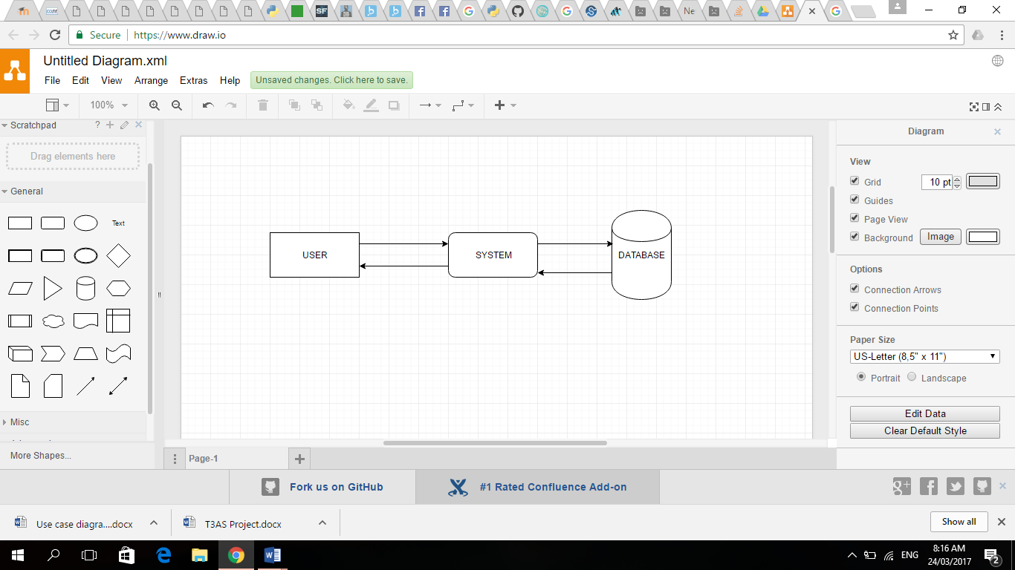The Database stores the user information and information related to the completion of user requests. The database sends and receives data to and from the System.

Figure System Components

It is important to note that the user can not directly interact with the database. This maintains the integrity of the database.

# Conceptual Design

Figure Conceptual Design of TrackFit System

The above diagram illustrates the concept of the TrackFit System. The system will be modelled using this design concept.

Class Diagrams

# TECHNOLOGY

Software and Programming Language

TrackFit is a highly technical system.

The software is designed using Android Studio where the system is modelled using Java. Java provides more flexibility that C or C++ allows. Android Studio allows easy design of the user interface

Database

The Database is designed using MySQL.

Hardware

Devices

TrackFit is being designed a mobile application. Therefore, any mobile device classified as a ‘smartphone’, with the minimum specifications of the application, will allow the application to operate as designed.

‘Smartphones’ are a modern technological device that most persons between the ages of 18 – 28 years, the scope of the project, possess. The prevalence of android devices over iOS devices, mainly due to cost, makes it more feasible to design the application for android devices, ensuring a large market of potential users.

The mobile device is paired with any mobile android wear device, for example a watch. The watch sends the wearer’s heart rate to the application for processing. The mobility of the wear device allows the user to perform a range of activity without having to hold the device which would limit the number of activities the user can perform.

Login

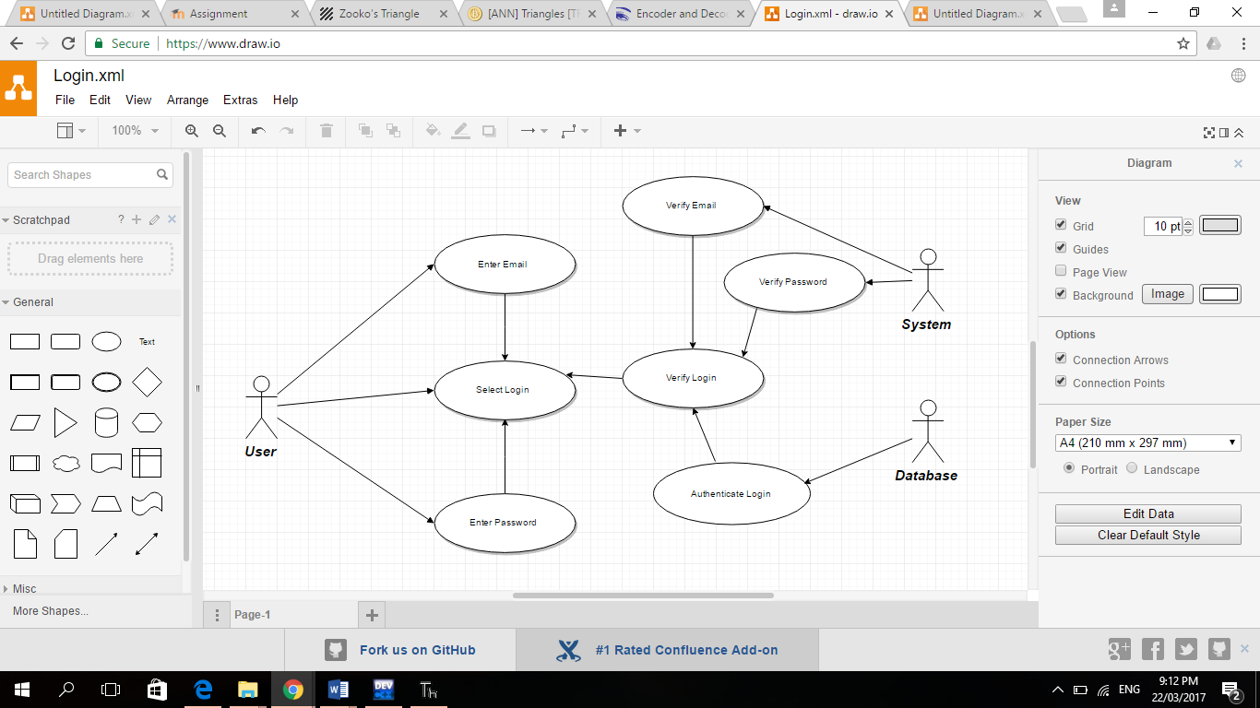

Register

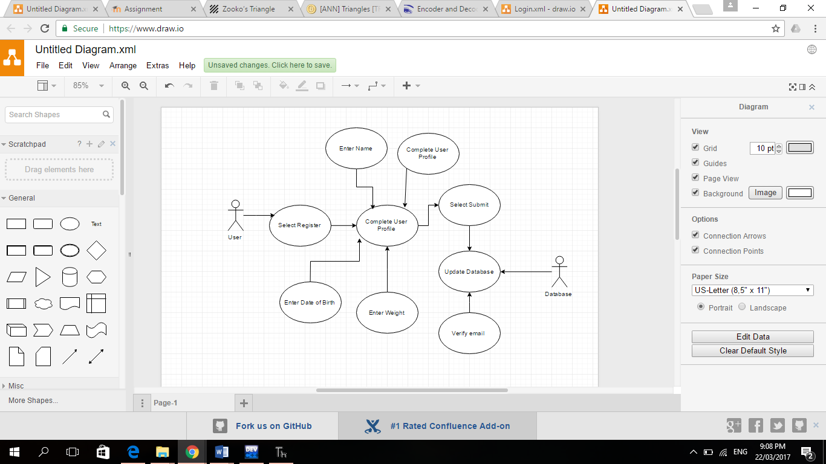

Workout

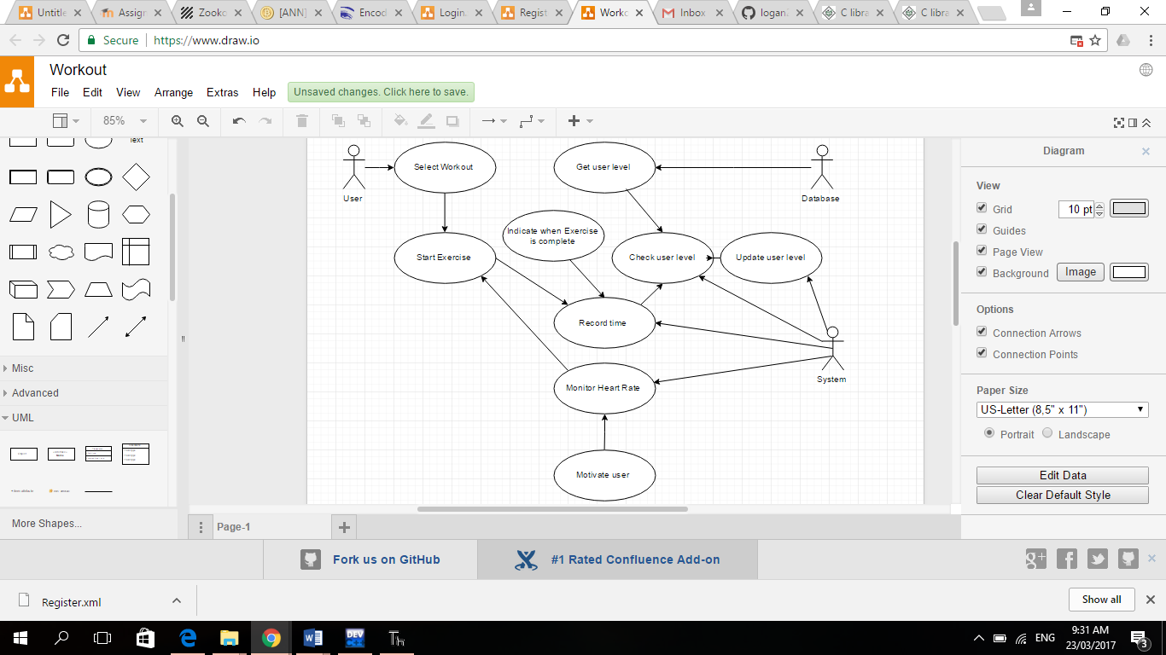

Navigation

